Output:

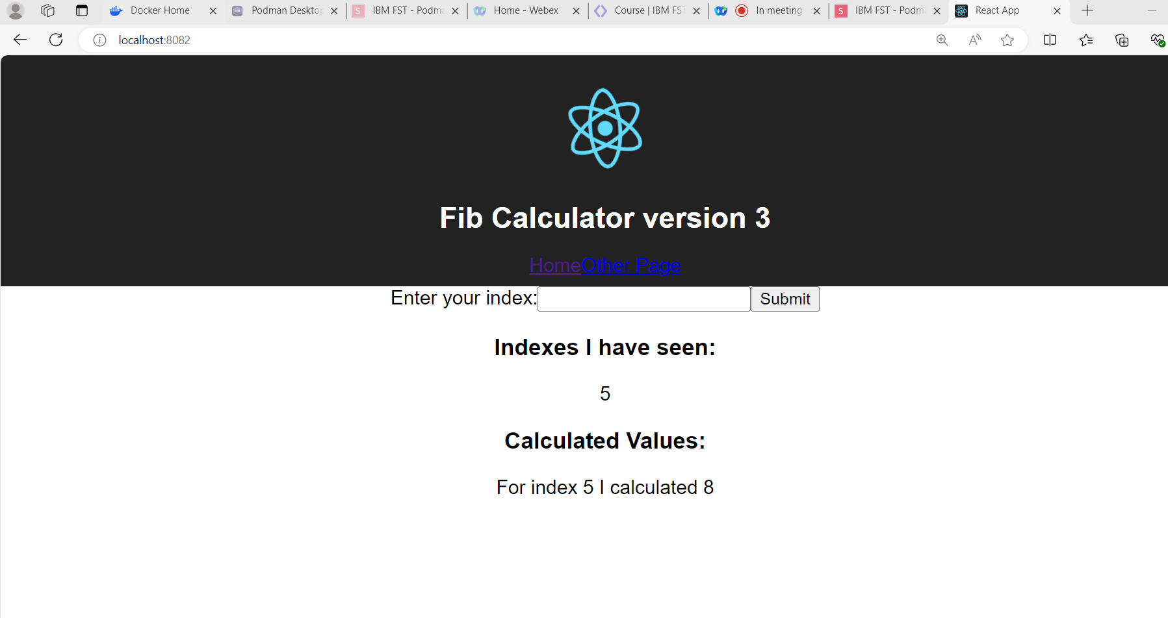

Client -> Dockerfile

Server -> Dockerfile:

Worker -> Dockerfile:

Docker-Compose File:

